United Drug Business Development Independent Award

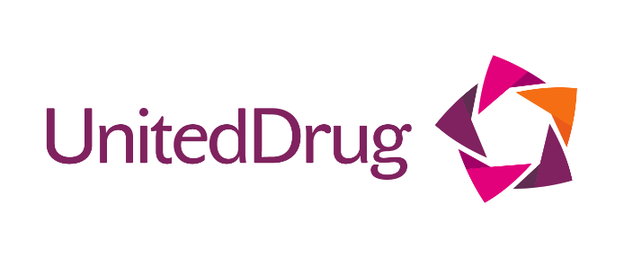
* Open to all pharmacies with less than 3 stores

The United Drug Business Development (Independent) Award serves to recognise those who have
displayed success in terms of sales, training, recruitment, customer service, product development or other areas of business development.

Entries should demonstrate an innovative approach to creating new business, and outline the
timescales, objectives and results of the initiative.

Judges will look for a business initiative that stands out in terms of its scale, scope or approach. This award will credit the company that has demonstrated excellent levels of customer service backed by clear standards and adequate monitoring performance.

Account will be taken of:

- Clear demonstration of an identified need and personal rationale along with details of the process of implementation from concept to design, planning and results

- Evidence will be displayed for plans for further research and development

- Evidence of a sound business plan, sales and marketing strategies

- Strong leadership skills with the ability to drive the business forward Innovation and ambition
Guidelines for entry:
- Application forms for awards entries must be received via email by midnight, 25th March, 2022.
- Please restrict answers to no more than 350 words unless otherwise stated.
- Please be aware this is an individual entry for an Independent Pharmacy.
- Supporting material such as annual reports, graphs, videos, financial data and so on may be included.

Details
Pharmacy Name:
Town/City:
Pharmacy Manager Name:
Pharmacy Phone Number:
Email:
Mobile Number:

Name of person nominating (If different from above):
Pharmacy Name:
Town/City:
Pharmacy Phone Number:
Email:
Mobile Number:
Is the person/team aware of nomination? | Y/N
Names of local newspaper and radio stations you would like to see coverage in:

PR & Marketing contacts:

The next section of the application involves 5 questions. Questions 1- 4 must be answered in no more than 350 words, and question 5 in no more than 1,000 words
Supporting material is permitted and is not included towards your word count.
Please send a maximum of four high res images to accompany your application. All images must contain full captions.
Deadline for entries: 25th March, 2022
1. Please outline the key challenges for the business that were tackled by this development initiative:

2. How did you identify, engage and involve stakeholders and how were your staff involved in supporting this development initiative?

3. What were the main objectives of this initiative and how did the pharmacy business and the team set about achieving them?

4. Please give evidence of the impact this business initiative has had on the pharmacy business and on the community it serves:

5. Please outline why this project deserves the United Drug Business Development (Independent) of the Year Award 2022:

