AYA Category Development Award 2020

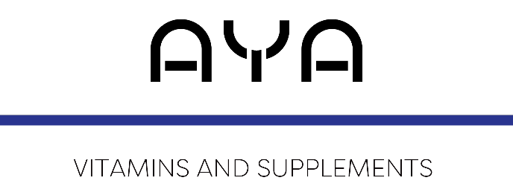

Guidelines for entry:
- Application forms for awards entries must be received via email or post by midnight, 31st March, 2020. Please email the application to: aoife@ipn.ie
- Please restrict answers to no more than 250 words unless otherwise stated.
- Supporting material such as annual reports, graphs, videos, financial data may be included.
Details
Pharmacy Name:
Town/City:
Pharmacy Manager Name:
Pharmacy Phone Number:
Email:
Mobile Number:

Name of person nominating (If different from above):
Pharmacy Name:
Town/City:
Pharmacy Phone Number:
Email:
Mobile Number:
Is the person/team aware of nomination? | Y/N
Names of local newspaper and radio stations you would like to see coverage in:

PR & Marketing contacts:

The next section of the application involves 6 questions. Questions 1- 5 must be answered in no more than 350 words, and question 6 in no more than 1,000 words
Supporting material is permitted and is not included towards your word count.
Please send a maximum of four high res images to accompany your application. All images must contain full captions.
Deadline for entries: 31st March, 2020
- Please describe the pharmacy which is being nominated for this award and the category which they have developed:

2: Please describe staff training strategies specific to this category and how they have been implemented and monitored:

3. Please give examples of the measurable benefits of the development initiative:

4. Please outline the pharmacy’s understanding of shopper behaviour in this area and how it has been considered in developing this category:

5. Please demonstrate the measurable benefits – including examples – from this project or initiative:

6. In no more than 1,000 words, please describe why you/they deserve the AYA Vitamins, Category Development Award 2020 title:

